**Justin Thoreson**

**CPSC 3300 Fundamentals of Databases**

**Application Description and Demonstration**

**04 June 2021**

Home Page: <http://css1.seattleu.edu/~thoresonjust/db3300/db_home.html>



The home page has four buttons: Describe, Select, Insert, and Delete. Each one corresponds to which type of query one would like to execute on the database. Clicking on a button will redirect the user to the page where they can execute that specific query. I have provided some examples of those pages below.

Describe:

To execute a DESC query, use the dropdown menu to select the name of the table you want to get the details of and then hit the submit button.



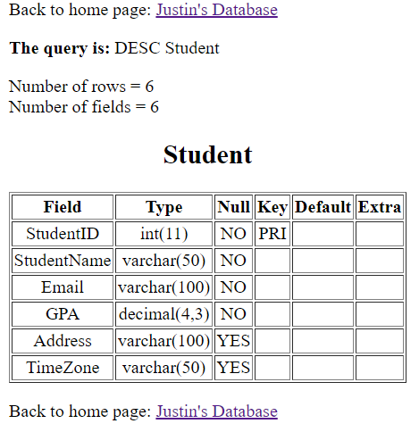On selecting the Student table:

Select:

To select data from the database, you must select a table with the dropdown menu. All other fields are optional. If no attributes are provided under the SELECT box, the selection will default to selecting all attributes (*).

Selecting 10 tuples from the Event table:

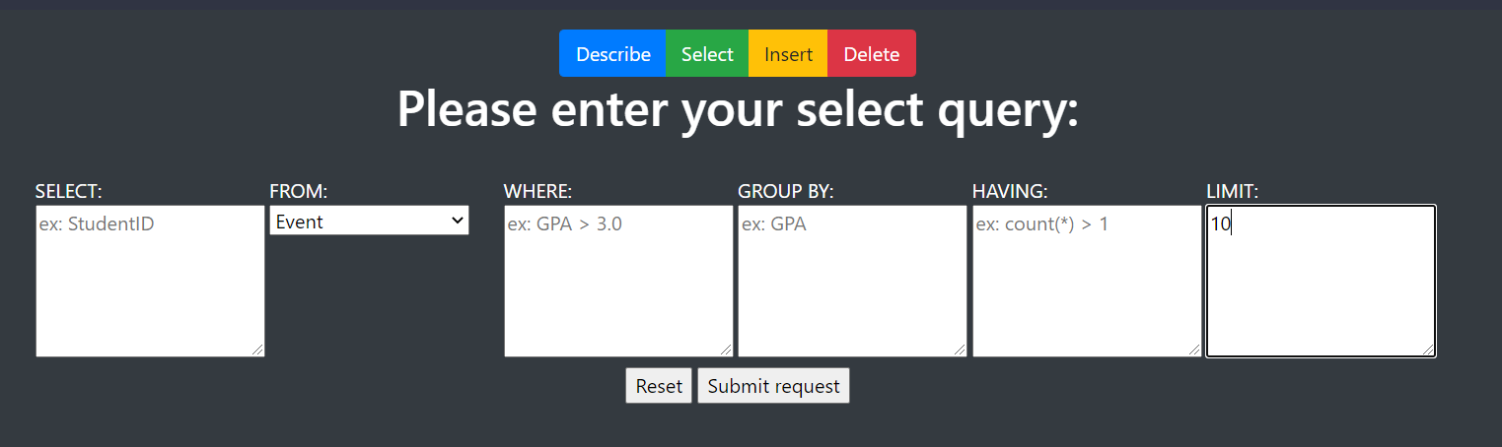

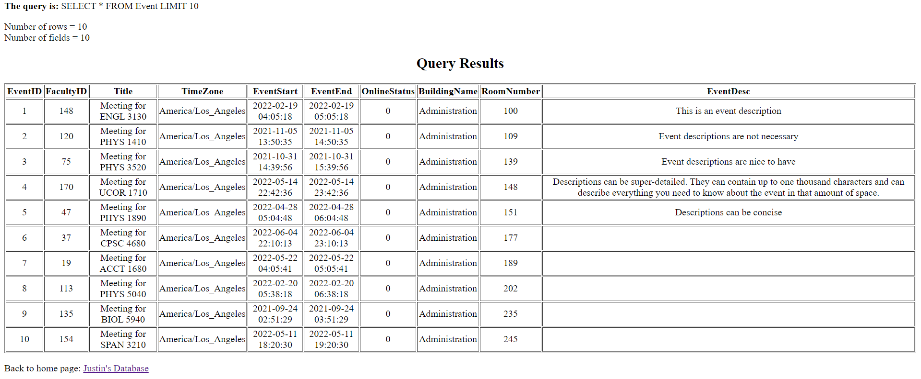

Aggregation functions can also be applied. For example, we can select the number of students at each GPA level:

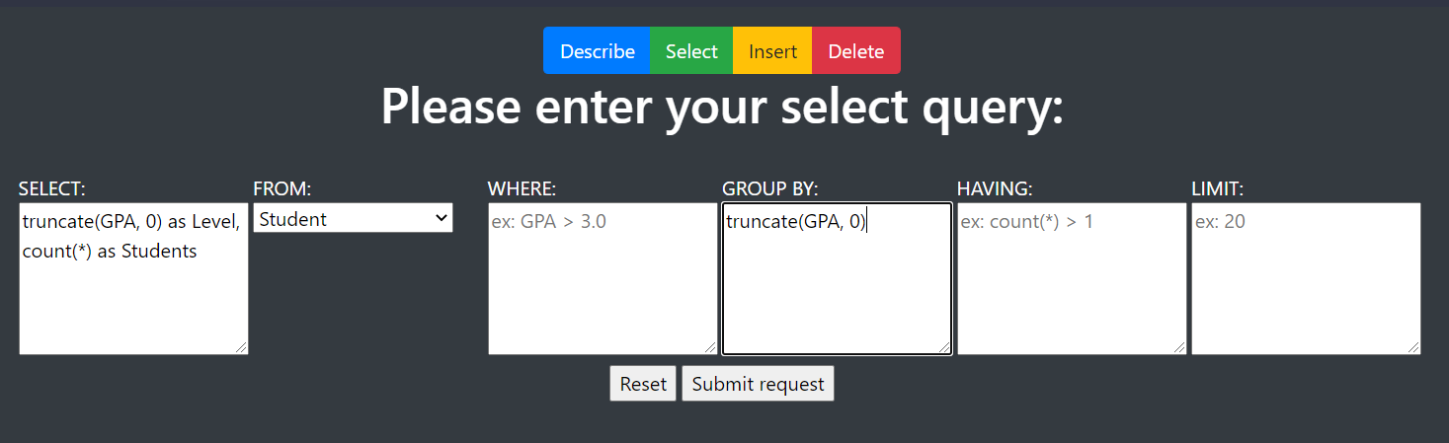

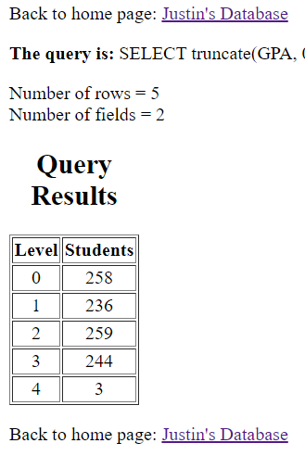

Insert:

To insert a tuple into a table, the attributes must be provided in order as shown in the describe query for the respective table. For example, we can select the Location table and provide the necessary attributes to insert:

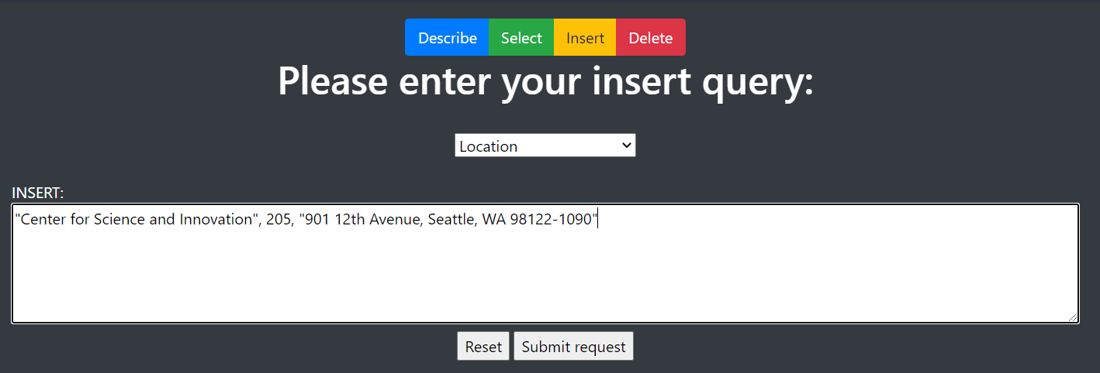

After inserting, we can select to check that the insertion processed as expected:

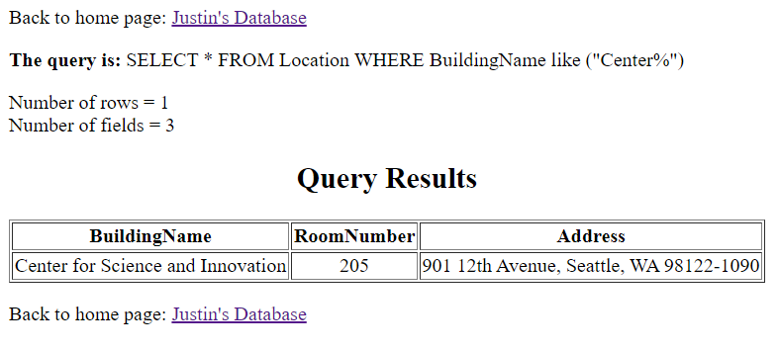

Delete:

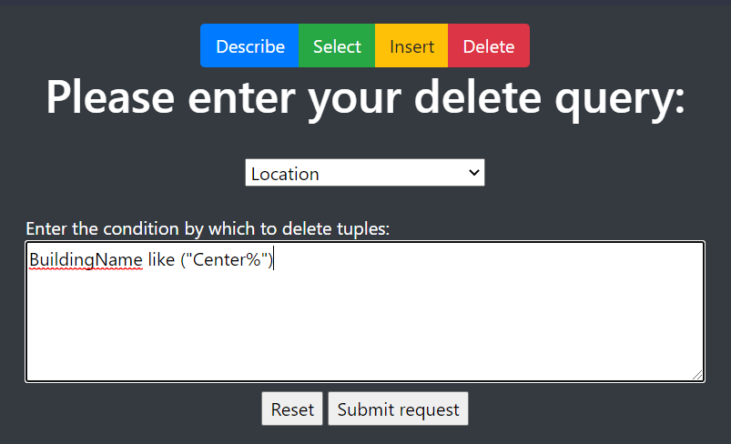To delete tuples, select the table to delete from then apply the conditions by which to delete. For example, we can delete the last tuple that we inserted above with the following:

Then we can use the same select query from above to ensure that the tuple was deleted as expected:

